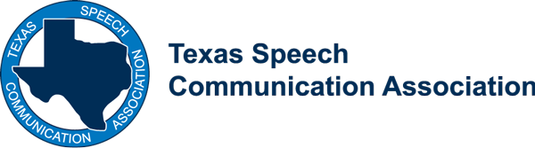
TSCA Faculty Convention Package

The Texas Speech and Communication Association is pleased to offer 2 complimentary Convention Packages to faculty members in Texas to attend Convention in Houston, October 5-7, 2017.

Eligibility: Applicants must be full-time faculty members in a speech communications department at an accredited college or university who are not members of TSCA and have never attended convention.

Selection Process: Applications will be accepted through September 1, 2017. The Executive Council will review applications and select two applicants to receive the free packages. Selection will be announced September 12, 2017.

Directions: Please complete the following application and return to Colin Malinak, cmalinak@smhall.org, no later than September 1, 2017.

Name
Last Name | First Name | Middle Initial

Institution
Name | Department | Department Chairperson

Position
Title | Current Teaching Assignment | Area of Research Focus

Do you have additional responsibilities on campus (sponsor a student organization, coach a team, etc.)? If so, please explain.

What professional organizations are you currently a member of?

What other professional activities do you participate in?

Please look at the TSCA website, www.etsca.com, look at the interest groups and committees: What looks interesting or helpful to you?

How did you find out about this opportunity?

Why haven’t you joined TSCA and what would make you consider joining as a sustaining member?

Why should we choose you to receive a free membership and convention package?

